40.13: a) 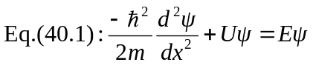
Left-hand side: 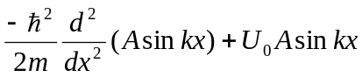
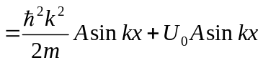
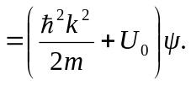
But 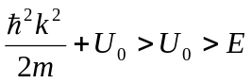 for constant 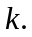 But 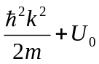 should equal 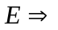no solution.
b) If 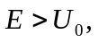 then 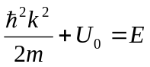is consistent and so 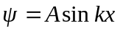is a solution of 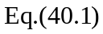for this case.

